Project Book

sound-IT

Lior liberov 315199059 kevYn krancenblum 332531235

‏2022

# Table of Contents

Table of Contents 1

1 – Introduction & Problem Definition 3

2 - Literature review 4

What Are Emotions? 4

The Link Between Facial Expressions and Emotions 6

Upscaling 8

The Link Between Music and Emotions 8

The Influence of Colors on Emotions 13

MuSe V3 18

Jukebox 18

Face Recognition 19

Body Language Recognition 19

Lip Reading 19

Neural Network 20

Convolutional Neural Network 22

Method & Tools 22

Architecture & General Concept 22

Centrally-Located Hardware Type 22

Data Storage 22

Operating System 23

Equipment 23

Development & Maintenance Tools 23

Body Language Recognition 24

Realization 24

4.1 – Development Process 24

Literature Review Summary 28

Results 28

3 - Objectives 29

3.1 - Application Client\Expert 29

3.1.1 - Main Client\User 29

3.1.2 - Application Expert\s 29

3.2 - Goals 29

3.2.1 – General Background 29

3.2.2 - Project Goals 29

3.2.3 - Future Goals 29

3.3 - Problems 30

3.3.1 - The crux of the issues in the current scenario. 30

3.3.2 - The issues that the system addresses. 30

3.2.3 - Issues that may arise from the system. 30

3.4 - Integration into the organization's objectives - the organizational/business relationship 30

3.4.1 - The organization's objectives, strategy 30

3.5 - Factors involved 30

3.5.1 - Management 30

3.5.2 - Professional teams - the development teams 30

Appendices 31

Yearly Work Plan 31

Risk Management 32

Bibliography 35

# 1 – Introduction & Problem Definition

When film first entered the art world, it was either accompanied by a live band or was silent. Others have even called silent films "the giant fool." Chaplin's final silent picture, "Modern Times" (1936), marked the end of the silent film format. To realize the union of audiovisual painting and sound and so increase the number of moviegoers, the era of sound films was formally inaugurated.

Music may enhance the quality of a film and has a huge impact on how it conveys emotion.

Our findings indicate that music has a considerable effect on the expression of emotion in a given scenario.

In addition to taking a significant amount of time and costing $44.4 million, according to LIONGATE's annual financial report (LIONS GATE ENTERTAINMENT CORP., 2022), using existing music requires a significant amount of money (not a one-time payment) and a significant amount of bureaucracy, which is a problem for independent filmmakers and/or YouTubers who do not have access to certain songs due to copyright protection laws and do not have large sums of money.

If we can develop a system that uses a neural network to receive films of specific scenarios, we will be able to compose music that reflects the emotion expressed by a scene. Then, we may integrate the music with the scene so that it is altered based on a collection of collected data, so determining the optimal fit for the scene.

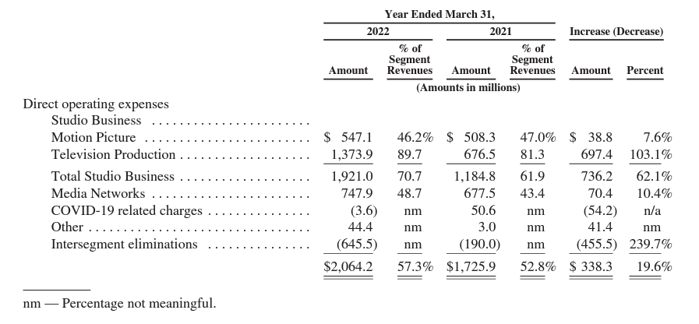

Figure 1: LIONSGATE ENTERTAINMENT CORP. expenses report. The Other category includes costs associated with making music. Source: (LIONS GATE ENTERTAINMENT CORP., 2022)

# 2 - Literature review

## What Are Emotions?

Emotion is a multi-staged chemical and neural integration process (Lindsey, 1951). In accordance with Mehrabian and Russell's PAD (Pleasure-Arousal-Dominance) model, emotions are evaluated based on pleasure, arousal, and dominance. The pleasure index evaluates the pleasantness or unpleasantness of the feelings, from acute unpleasantness to intense pleasantness (for example, anger and fear are at one end of the index, while joy and calm are at the other end). The arousal index assesses the level of emotional arousal, ranging from sleep to frenetic enthusiasm (for example, boredom is on the anesthetizing side of the index, while sadness is on the arousing side).

The dominance index measures how well the person can control this emotion, which ranges from a state of dependence (an overwhelming emotion in which the person is not in control) to dominance (an emotion in which the person is in control) (for instance, fear or sadness are emotions in which the person is in a state of dependence, whereas joy is an emotion in which the person is in a state of dominance/control) (Bakker, van der Voordt, Vink, & de Boon, 2014).

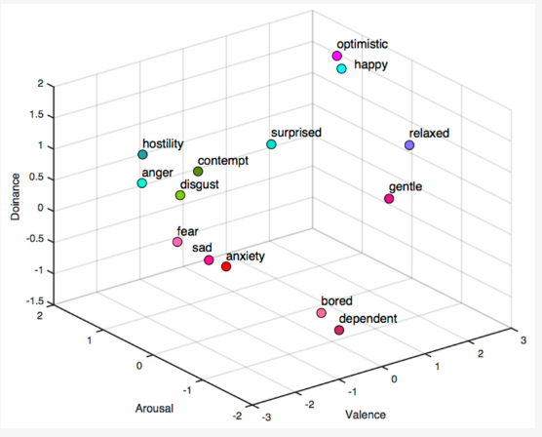

Figure 2: Taxonomy of emotions according to the PAD model. Source: (Shu, et al., 2018)

In addition, according to Robert Plutchik, an emotion is caused by an event that our brain perceives through sensory input, which is then translated into an emotion and a level of physiological alertness that compels us to act in response to that event (for example, the loss of a mother is interpreted as an event of abandonment by our mind, which makes us feel sad and autonomously dysfunctional, resulting in crying and then searching for that lost mother or her replacement). In addition, Plutchik identified eight emotions: joy, trust, fear, surprise, sadness, disgust, anger and anticipation (Plutchik, 2001).

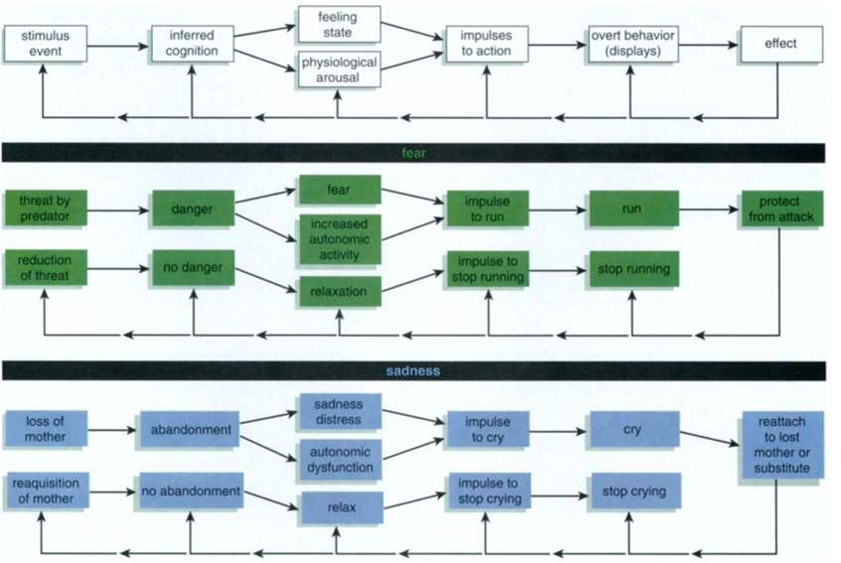

Figure 3: Diagram depicting the origin of the feeling, its consequences, and instances. Source: (Plutchik, 2001)

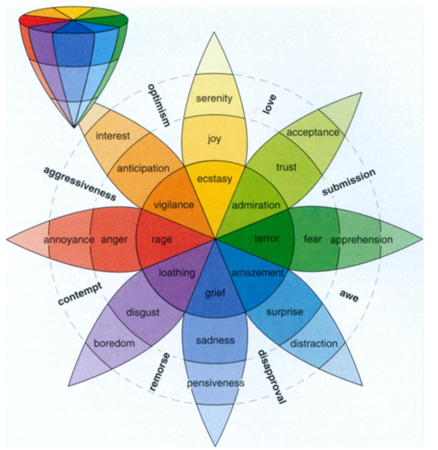

Figure 4: Plutchik's wheel of emotions. Source: (Plutchik, 2001)

## The Link Between Facial Expressions and Emotions

Facial expression is the consequence of a gesture or facial expression that reveals the position of the muscles in a person's face. It is a form of nonverbal communication and a crucial means of conveying emotions, intentions, objectives, and opinions to others ( Lambert, et al., 2014). Nowadays, computers are commonly used to anticipate facial expression pointing systems for services by manually selecting emotions for the level of happiness with a service displayed on a computer screen. On occasion, the emotional state of a person selected on the screen is deemed inaccurate as an indicator of client happiness. Real-time facial expression detection enabled by artificial intelligence can improve the system's accuracy. So that it can directly recognize the facial expressions of customers, for example, when they submit their payment at the cash register.

Using the dataset of emotion identification based on facial expressions, the authors propose testing the accuracy of successful predictions of 7 (seven) facial expressions, namely happy, sad, angry, afraid, surprised, neutral, and disgust, in real time.

The following datasets are currently available for face expression recognition:

AffectNet:

Automated emotional computing in a natural setting is a difficult topic in computer vision. Current databases of face expressions in nature are limited and focus mostly on specific emotions (also known as the categorical model). There are very few face datasets with annotations for emotional computing based on the continuous dimension model (e.g., pleasantness and alertness). To address this need, a new database of emotions based on facial expressions in nature (named AffectNet) has been compiled, annotated, and made available to the public. AffectNet comprises over one million facial photos obtained from the Internet by querying three of the most popular search engines with 1,250 emotion-related keywords in six languages.

The existence of seven distinct facial expressions and the strength of valence and arousal were manually assessed on approximately half of the recovered photos. AffectNet is the largest library of facial expressions, valence, and arousal in nature, allowing for research into the automatic recognition of facial expressions in two distinct emotion models. Two baseline deep neural networks are used to classify images and predict the intensity of pleasantness and alertness in the categorical model. Several benchmarks demonstrate that the baselines of their deep neural networks outperform standard machine learning approaches and commercial facial expression detection systems (Mollahosseini, Hasani, & Mahoor, 2017).

Extended Cohn-Kanade Dataset (CK+) :

The Cohn-Kanade Extended Dataset (CK+) contains 593 video sequences from a total of 123 people, ranging in age from 18 to 50 years old and representing a diversity of races and genders. Each video depicts a facial transformation from a neutral to a focused peak expression at 30 frames per second (FPS) with a resolution of 680x490 or 640x480 pixels. 327 of these videos are categorized with one of seven expression categories: anger, contempt, disgust, fear, happiness, sadness, and surprise. The CK+ database is regarded as the most exhaustive database for laboratory-controlled facial expression classification and is utilized by the majority of facial expression classification algorithms (Lee, Wang, & Wong, 2020).

FER-2013:

The training set of FER-2013 contains over 28,000 tagged photos; the dataset was constructed by gathering Google image search results and synonyms for each emotion. Each image in FER-2013 is classified with one of seven emotions, including happy, sad, angry, fear, surprise, disgust, and neutral, with happy being the most frequent emotion and providing a random guess baseline of 24.4%.

Number of photographs contained in the FER-2013 dataset:

|  |  |
| --- | --- |
| **Micro Expression** | Total DataSet |
|  |  |
| **Angry** | 3995 |
| **Disgust** | 436 |
| **Fear** | 4097 |
| **Happy** | 7215 |
| **Sad** | 4830 |
| **Surprise** | 3171 |
| **Neutral** | 4965 |
| **Total** | 28709 |

Where each image has a 48x48 pixel resolution

Emotions:

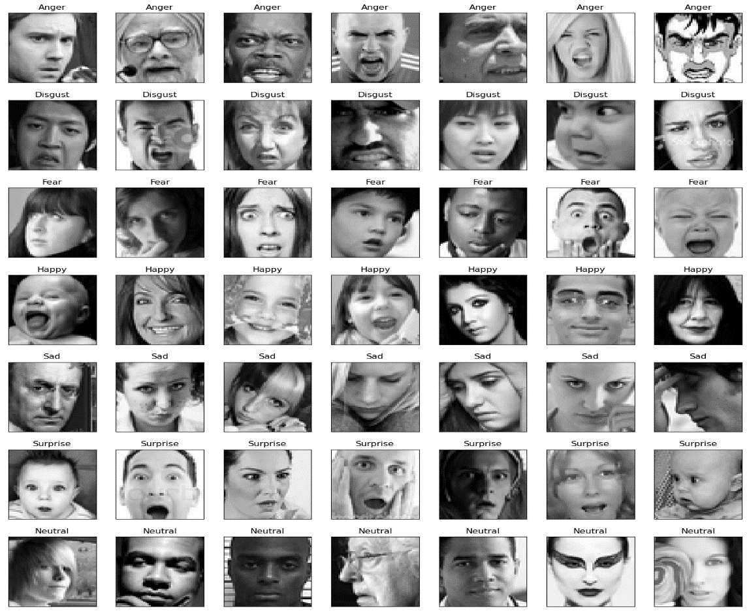

## Upscaling

ESRGAN is an image enhancer that interpolates intermediate pixel values using artificial intelligence. The method augments data using models that have already been developed. The more closely the training data set resembles the expected inputs and outputs, the better the model will perform for the use case (Wang, et al., 2018).

Theoretically, anyone with a large sample set of images, significant computer power, and sufficient time may train their own model for high-end retro video game visuals. However, for the purposes of these tutorials, we will only employ pre-trained models developed by others, which by default scale input images by a factor of 4.

Grid interpolation is a handy feature of ESRGAN that allows you to successfully combine the results of two models into one. This is an intriguing aspect of the algorithm.

Typically, the duration of ESRGAN is 130 seconds.

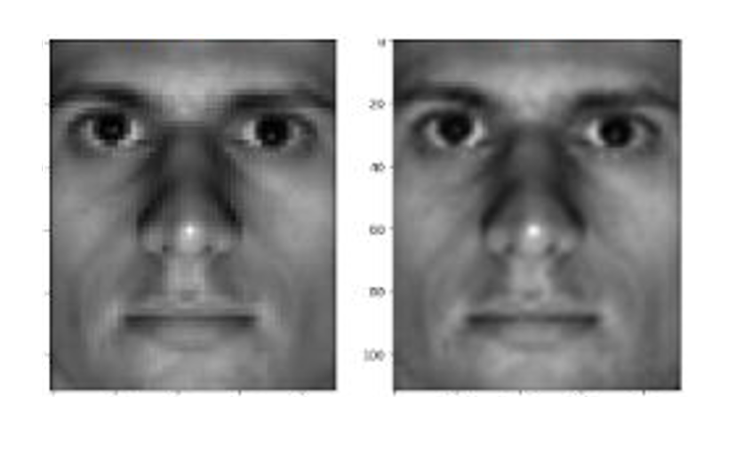

Figure 5: The ESRGAN algorithm in operation (left - input image, right - output image)

## The Link Between Music and Emotions

To determine whether music affects our emotions, researchers from the Department of Psychology at the University of Belgrade invited 32 students to participate in two experiments: the first experiment consisted of classifying film clips and music to the emotion that appears on Plutchik's Wheel of Emotions.

And in the second trial, participants rate the degree to which the music complements the segment of the film. Those from the first experiment did not take part in the second experiment (Pavlovic & Markovic, 2011).

Preparing for the experiment - five individuals, including the experiment managers, selected 32 silent film clips of around one minute in length and 32 musical clips of approximately the same length. The following criteria were used to gather the sections:

1) To preserve unambiguous emotional categorization, Plutchik's Wheel of Emotions contained one dominating feeling for each film and musical part.

For the purpose of the experiment, each emotion was represented by four movie clips and four music clips (8 emotions * 4 movie clips = 32 movie clips, 8 emotions * 4 music clips = 32 music clips).

2) To preserve variation, the genres of the film and music parts were varied.

3) Film clips featuring conversations and monologues, as well as songs with lyrics, were excluded from the experiment to decrease the possibility of words to elicit a particular emotion instead of the content heard or seen.

4) Less popular pieces were chosen to limit the potential that prior knowledge of the film or the music would influence the emotional experience throughout the trial.

The course of the experiment - 64 segments were presented to each of the two participant groups. Each group categorized one-half of the videos (16 movie clips and 16 music clips). On a 1 × 1 meter screen, a 1 x 1 meter LCD projector displayed film clips, while stereo speakers played music clips. The participants sat around 3 to 4 meters away from the speakers. The participants were tasked with classifying the segments immediately following their presentation using a check list. The checklist included Plutchik's eight emotions - joy, trust, fear, surprise, sadness, disgust, anger, and anticipation - as well as a ninth option, "causes no emotion." Participants were instructed to identify the predominant emotion elicited by the film/music portion. The classification duration was unrestricted. The approximate length of the experiment was sixty minutes.

The findings of the experiment - Each film and music segment was matched to a specific emotion, with the matching percentage ranging from 50 percent (16 participants matched the segments to a single emotion, while the remaining participants were dispersed among the other seven emotions) to 100 percent (all 32 participants matched each segment to a single emotion).

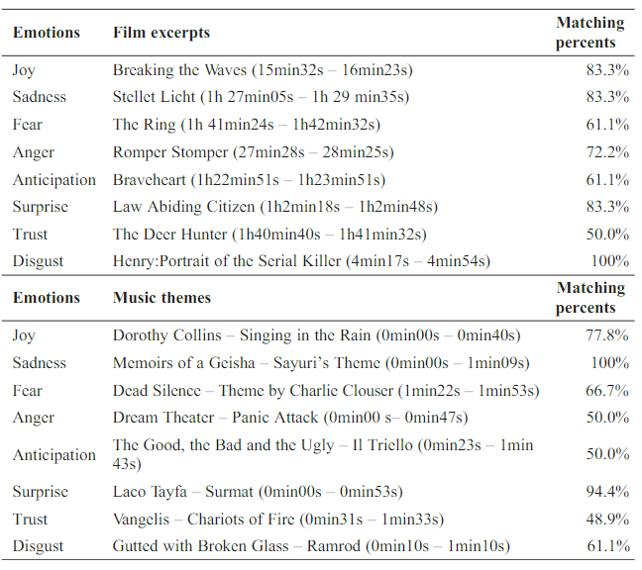

Figure 6: Findings of the first experiment. Source: (Pavlovic & Markovic, 2011)

After completing the first experiment, they began the second one.

Preparation of the experiment - 16 combinations of movie clips and music were created from the collection of the previous experiment: eight combinations in which the music and the movie express the same emotion (for example, a happy movie clip with happy music), and eight combinations in which the music and the movie express emotions opposite of each other (for example, a happy movie clip with sad music.) Each combo lasted around sixty seconds.

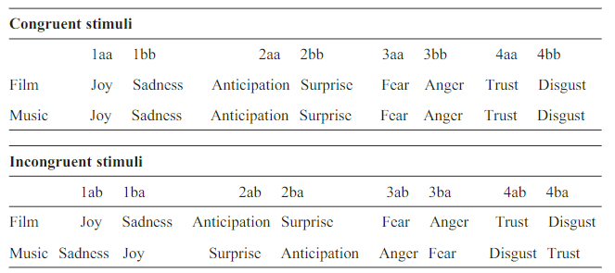

Figure 7: A table depicting the movie clip and music pairings. Source: (Pavlovic & Markovic, 2011)

The course of the experiment - As in the first experiment, the participants were seated in a room where the film was projected using a meter-by-meter LCD projector and the sound was played through stereo speakers 3-4 meters away; however, in contrast to the first experiment, the film and music were played simultaneously rather than separately according to the previously determined combinations. On a scale from 1 (very low intensity) to 7 (very high intensity), participants were required to rate the intensity of the emotions elicited by these pairings. As in the last experiment, participants were not time-limited, although in contrast to the prior experiment, this experiment required less time (this experiment took approximately 15 minutes compared to the previous experiment which took approximately 60 minutes).

Moreover, the participants were separated into the following two groups:

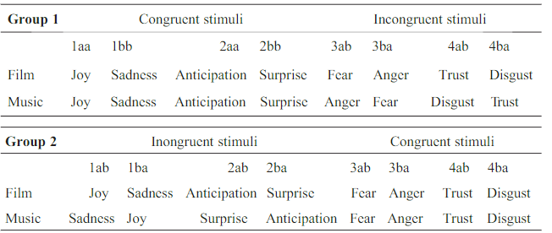

Figure 8: The manner in which the second experiment's groups were separated. Source: (Pavlovic & Markovic, 2011)

The findings of the experiment involved grading all combinations of emotions on a scale ranging from 1 to 7, as previously described : 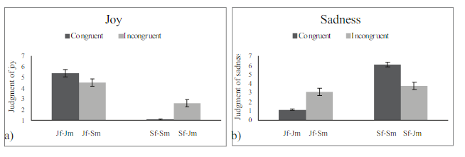

Figure 9: The level of intensity for the emotions joy (on the left) and sadness (on the right) (Jf-Jm signifies a combination of a joyful movie with happy music, Jf-Sm a combination of a joyful movie with sad music, Sf-Sm a combination of a sad movie with sad music, and Sf-Jm a combination of a sad movie with joyful music). Source: (Pavlovic & Markovic, 2011)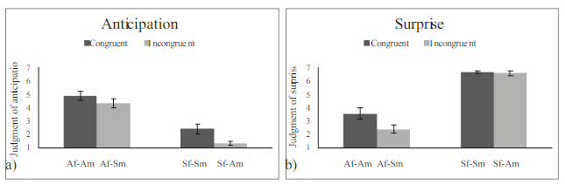

Figure 10: The intensity of the emotions anticipation (on the left) and surprise (on the right) (Af-Am denotes a combination of a suspenseful film with tense music, Af-Sm denotes a combination of a suspenseful film with surprising music, Sf-Sm denotes a combination of a surprising film with surprising music, and Sf-Am denotes a combination of a surprising film with tense music). Source: (Pavlovic & Markovic, 2011)

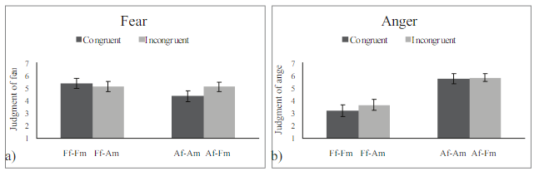

Figure 11: The intensity of the emotions fear (left) and anger (right) (Ff-Fm indicates a terrifying movie with scary music, Ff-Am means a scary movie with angry music, Af-Am means a scary movie with angry music, and Af-Fm means an angry movie with scary music). Source: (Pavlovic & Markovic, 2011)

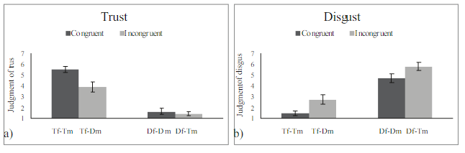

Figure 12: The amount of intensity for the feelings trust (left) and disgust (right) (right) (Tf-Tm implies a combination of a trustworthy film with trustworthy music, Tf-Dm means a combination of a trustworthy film with revolting music, Df-Dm means a combination of a revolting film with revolting music, and Df-Tm means a combination of a revolting film with trustworthy music). Source: (Pavlovic & Markovic, 2011)

Conclusion - based on the results of the experiment, it is clear that music has an effect on our emotions, and that pairing it with specific situations in films enhances the emotion expressed by the scene (sometimes a deliberate mismatch also contributes to the intensification of the emotion as can be seen in the results of the feelings of disgust and anger).

## The Influence of Colors on Emotions

Researchers from the University of California conducted three separate experiments in order to determine whether or not color has an effect on our emotions. The first experiment tested whether or not the brightness and intensity of a color affects our emotions; the second experiment tested whether or not the color tone affects our emotions; and the third experiment tested whether or not achromatic colors (black, white, and gray) has an effect on our emotions. All three experiments were designed to determine whether or not color has an effect on our emotions.

Preparing for the experiment - 250 students (103 males and 147 women) participated in the first experiment. In the experiment, they painted color samples from the Munsell system onto cards measuring 7.6 by 12.7 centimeters. When the shades had varying degrees of brightness, they utilized 10 colors: red, yellow, green, blue, purple, reddish yellow, yellowish green, bluish green, and bluish violet. The cards were displayed on a gray background (with a value of 5 on the Munsell scale). The participants in the experiment were in a room lit by eight fluorescent lamps with a color temperature of 5000°K, which most closely resembles sunlight. This is necessary for the experiment to maintain optimal color display (its brightness, intensity, or hue will not be affected). The emotions were categorized and assessed using Mehrabian and Russell's PAD model (for example, in order to measure the level of pleasantness that the experiment participant feels from the color, they had to choose whether it is more happy or more horrifying, or whether it is more pleasing to the eye or disgusting).

The course of the experiment - The participants were separated into two groups. Each group rated seven to nine hues of the same hue but differing intensities. The participants were shown the colors once each time. The order of color presentation is organized so as to minimize drastic or negligible variations in color brightness. Once participants responded to one color, their survey forms were swapped with blank sheets when a different color card was presented. Participants were given a 5-minute break after the fourth color to optimize their focus on the subsequent colors.

The findings of the experiment - After arranging the results of the experiment, they discovered:

- When the brightness is high and the color intensity is low, the emotions are more pleasant.

- When the brightness is low and the color intensity is high, the emotions are more stimulating.

- When the brightness is low and the color intensity is moderate, the emotions exert less control over the individual.

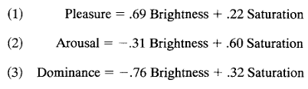

Equation 1: Which index of the PAD model is affected by brightness and color intensity

Following is a graphical representation of the brightness intensities on the indications of the anticipated alertness, pleasantness, and emotional dominance, which were determined using the aforementioned algorithms:

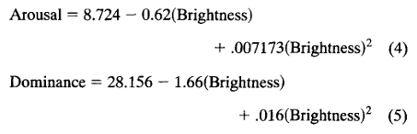

Equation 2: Computation of the anticipated arousal and dominance indices of the emotion as a function of color brightness intensity

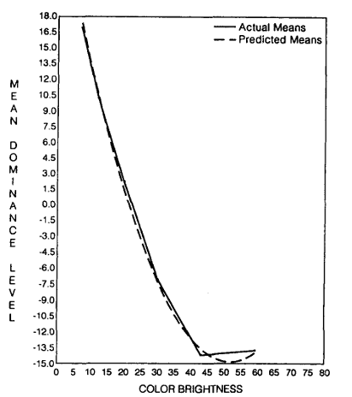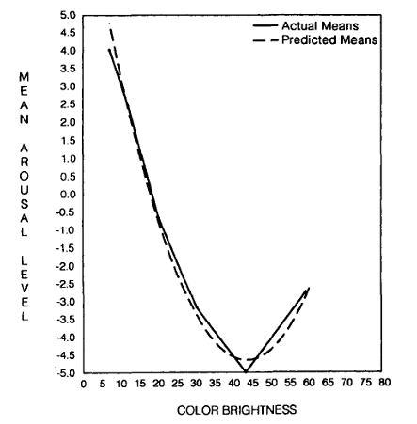

Figure 13: A graph demonstrating the level of emotional dominance as a function of the color's brightness (dashed line - predicted results, continuous line - true results)

Figure 14: A graph demonstrating the intensity of emotional arousal as a function of the color's brightness (dashed line - predicted results, continuous line - true results)

Second experiment:

Preparing for the experiment - In the second experiment, 25 University of California students (7 men and 18 women) were required to participate in order to pass a certain course. On panels, 10 hues were exhibited. The only distinction between the panels was their coloration, as their brightness and intensity were identical. The experimental room's parameters were identical to those of the last experiment.

The course of the experiment - Two people were tested simultaneously. Each participant rated their emotional response to 10 colors, all of which were of similar brightness and intensity and vary only in hue. The participants got instructions comparable to the first trial. After presenting five hues, participants were given a 10-minute break to minimize weariness. To prevent participants from assigning identical ratings, the tones were presented in a different order for each subject.

The findings of the experiment - As evidenced by the results presented above, the hue of a color affects human emotion:

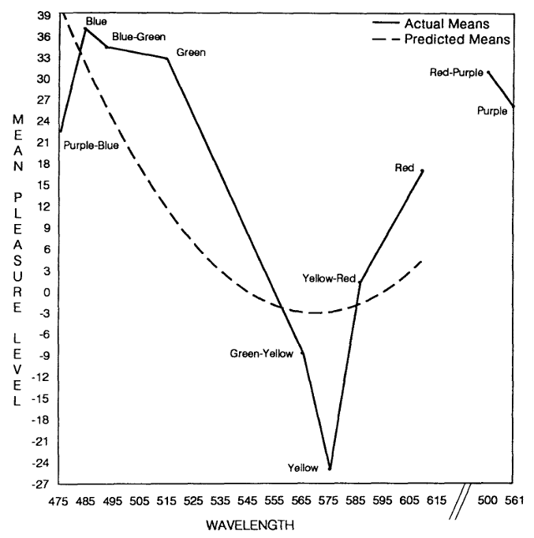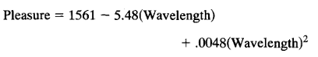

Figure 15: A graph demonstrating the level of pleasantness of the mood as a function of the color shade (dotted line - anticipated results, continuous line - genuine results)

Equation 3: The prediction function of Figure 15's results

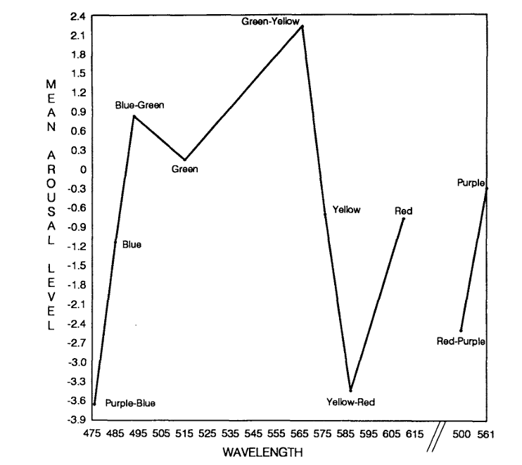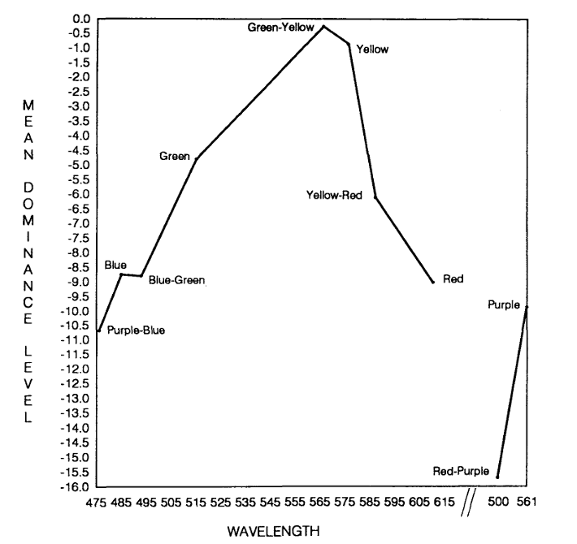

Figure 16: A graph demonstrating the degree of emotional arousal as a function of color hue.

Figure 17: A graph demonstrating the level of emotional dominance as a function of hues.

Third experiment:

Preparing for the experiment - Twenty-five students from the University of California (7 men and 18 women) were required to participate in the third experiment in order to pass a certain course. On panels, five achromatic tones (black, dark gray, gray, light gray, and white with respective MUNSELL values of 3, 12, 30, 43, and 79) were displayed. The only distinction between the panels was their coloration, as their brightness and intensity were identical. The conditions of the room in which the experiment was conducted were identical to those of the initial experiment.

The course of the experiment - Two people were tested simultaneously. Each participant judged their emotional response to the five identically bright and intense tones that vary only in their tone. Same instructions were given to the participants as in the first experiment. To prevent participants from assigning identical ratings, the tones were presented in a different order for each subject.

The results of the experiment - According to the results of the following experiment, achromatic colors have an effect on human emotions.

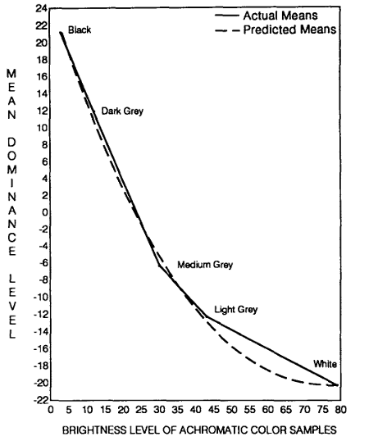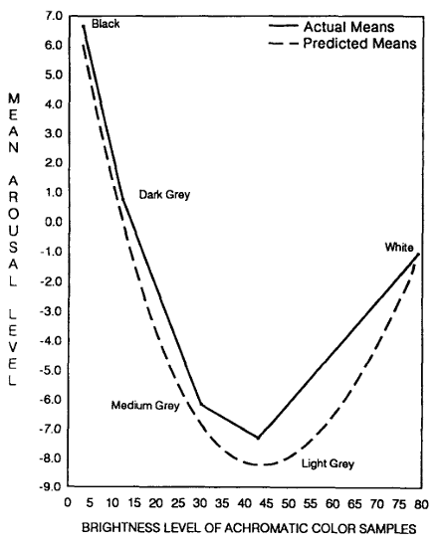

Figure 18: A graph illustrating the level of emotional dominance as a function of the achromatic tone (dashed line - predicted results, continuous line - true results)

Figure 19: A graph illustrating the degree of emotional arousal as a function of the achromatic hue (dashed line - predicted results, continuous line - true results)

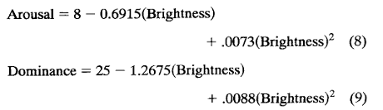

Equation 4: Prediction equations for evaluating arousal and dominance levels

Conclusion - Based on the results of the prior studies, it is clear that color, as well as its brightness, intensity, and shade, has an effect on a person's mood.

Regarding our project, we analyze the average color of the video and apply this information to the classification of sentiment.

Based to the aforementioned study and PAD graph, we observed:

yellow = Arousal=-0.6*2/13=-0.0923076923 Dominance=(8-1)*3/16=1.3125 Valence=-24*3/27=-2.66666666667 🡨 happy

green = Arousal 0.3*2/8=0.075 Dominance (8-4.5)*3/16=0.65625 Valence 33*3/39=2.53846153846 🡨 relaxed

blue = Arousal 0.3*2/8=0.075 Dominance (8-4.5)*3/16=0.65625 Valence 33*3/39=2.53846153846 🡨 relaxed

red = Arousal 0.3*2/8=0.075 Dominance (8-4.5)*3/16=0.65625 Valence 33*3/39=2.53846153846 🡨 relaxed

## MuSe V3

The MuSe (Music Sentiment) collection includes empathetic data for 90,001 songs. Its designers derived values for the emotive characteristics of valence (pleasantness), dominance, and arousal based on the Last.fm user-generated tags for each song. In addition, the dataset includes artist, title, and genre metadata, as well as a MusicBrainz ID and a Spotify ID, enabling researchers to contribute further metadata (Akiki & Burghardt, 2020).

## Jukebox

OpenAI Jukebox is a music composition system based on deep learning developed by the artificial intelligence research center OpenAI. It uses a neural network to construct musical compositions in a given genre and is capable of producing lengthy pieces of music with various variations. The system is trained on a database of songs in a given genre and is capable of producing new songs that sound similar to the training data. OpenAI Jukebox is capable of generating music in a vast array of genres, including pop, rock, jazz, and classical (Dhariwal, et al., 2020).

OpenAI Jukebox creates musical compositions using a deep neural network. The system is trained on a database of songs in a given genre and is capable of producing new songs that sound similar to the training data. The neural network is designed to understand the basic structure of the genre's music and to generate captivating new instances of the genre's music.

The best aspects of OpenAI Jukebox include its ability to create long pieces of music with several sections and variants, its ability to make music in a wide range of genres, and its training data that contains songs from a wide range of genres.

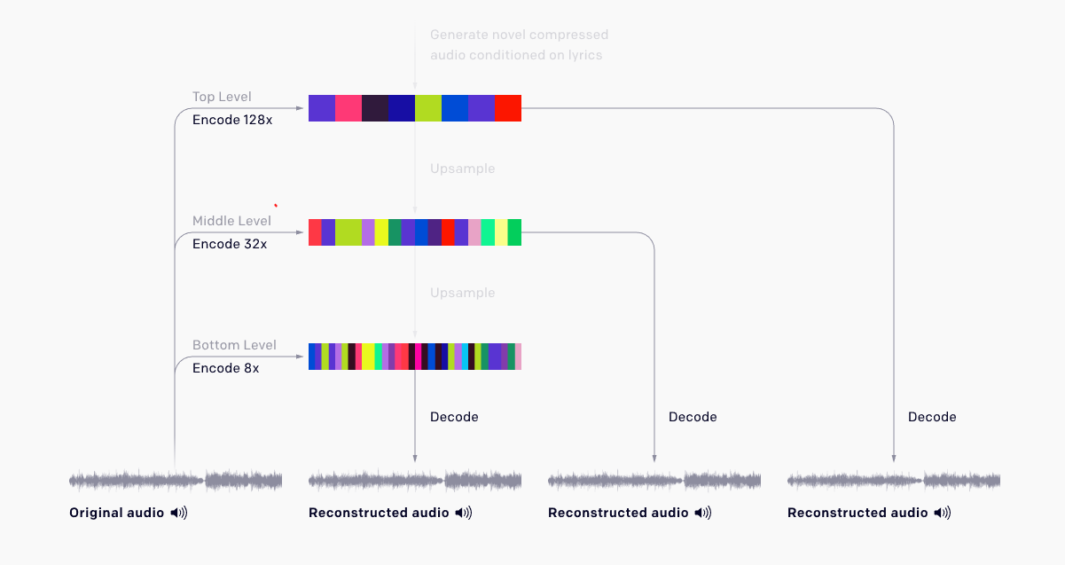

Figure 20: Jukebox encodes the music and, based on this encoding, generates new music at three distinct quality levels.

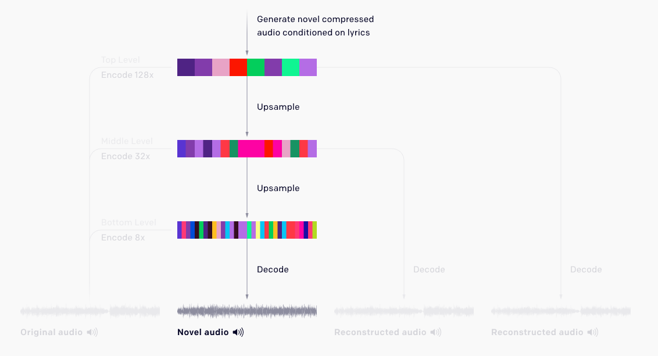

## Face Recognition

Facial expression is the consequence of a gesture or facial expression that reveals the position of the muscles on the human face as a type of non-verbal communication and a crucial means of expressing one's emotions, intentions, objectives, and ideas to others ( Lambert, et al., 2014). Nowadays, computers are commonly used to anticipate face expression scoring systems for services by manually selecting emotions for the amount of service satisfaction displayed on a computer screen. On occasion, the emotional state of a person selected on the screen is deemed inaccurate as an indicator of client happiness. Real-time facial expression detection enabled by artificial intelligence can improve the system's accuracy. So that it can directly recognize the facial expressions of customers, for example, when they submit their payment at the cash register.

The authors claim that the purpose of the study is to evaluate the accuracy of successful real-time predictions of 7 (seven) micro-facial emotions, including happy, sad, angry, afraid, surprise, contempt, and disgust, utilizing the facial emotion recognition dataset (FER-2013).

Face recognition technology is a system that builds a "template" of a target's facial image and then compares it to a database of photographs (in our case, videos that are stored locally on our computer) (Hamann & Smith, 2019).

Dlib and OpenCV are two open-source libraries used for face recognition. OpenCV use a neural network of the CNN kind to analyze the image for face recognition (Suwarno, 2020).

## Body Language Recognition

Body language recognition by emotions primarily summarizes the emotions that are represented by different poses in the existing body language literature, then extracts a number of key points of the human body parts from the influencing poses to connect the points and draw an abstract line map, and finally employs a computer vision algorithm of the abstract line map to recognize the emotions. Identifying key points in the human body to extract the coordinates of those points in the image by the camera, drawing the abstract line map of several poses of the human body through a clustering algorithm, and finally drawing the map that is input to a neural network of the CNN type (details below) and RNN( Recurrent Neural Network) + softmax algorithm for the classification of the emotion, and the information regarding the emotion presented by the different poses can be recognized (Mingming, Jiandong, & Yudong, 2020).

## Lip Reading

Based on the LipNet research, we detect emotion based on the words spoken in the video.

Lipreading is the task of decoding text from the movement of a speaker's mouth. Traditional approaches separated the problem into two stages: designing or learning visual features, and prediction. More recent deep lipreading approaches are end-to-end trainable. However, existing work on models trained end-to-end perform only word classification, rather than sentence-level sequence prediction. Studies have shown that human lipreading performance increases for longer words, indicating the importance of features capturing temporal context in an ambiguous communication channel. Motivated by this observation, researchers from the department of computer science of Oxford university, Google DeepMind, and CIFAR made LipNet, a model that maps a variable-length sequence of video frames to text, making use of spatiotemporal convolutions, a recurrent network, and the connectionist temporal classification loss, trained entirely end-to-end. To the best of their knowledge, LipNet is the first end-to-end sentence-level lipreading model that simultaneously learns spatiotemporal visual features and a sequence model. On the GRID corpus, LipNet achieves 95.2% accuracy in sentence-level, overlapped speaker split task, outperforming experienced human lipreaders and the previous 86.4% word-level state-of-the-art accuracy (Assael, Shillingford, Whiteson, & de Freitas, 2016).

## Neural Network

An artificial neural network (ANN) is a computational mathematical model based on brain or cognitive processes that occur in a natural neural network and is used in machine learning. This type of network often consists of a large number of interconnected information units (input and output), with connections passing through "hidden" information units frequently (Hidden Layers). The geometry of the link between the units, which provides information on the connection's strength, resembles the way neurons are connected in the brain (Aiken & Bsat, 1999).



Figure 21: A model of an n+2-layer artificial neural network. Source: 

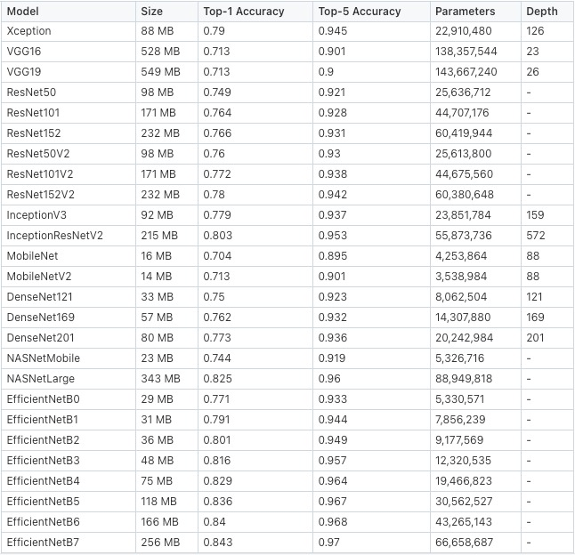

Table 1: VGG type neural networks available in the market. Source: https://gist.github.com/ogyalcin/052f2df49b3288e62086aa0e5fd25fcd#file-pre-trained-model-performances-csv

## Convolutional Neural Network

A Convolutional Neural Network (CNN) is one of the most commonly used architectures for image processing, image analysis, image classification, object recognition, segmentation, and face recognition, and it is also designed to be exceptional at pattern recognition. CNN works by lowering the image's size, that is, by working with small portions of the huge image in a manner that does not compromise the image or its quality, hence reducing the calculation time for each image (Liu & Huang, 2019).

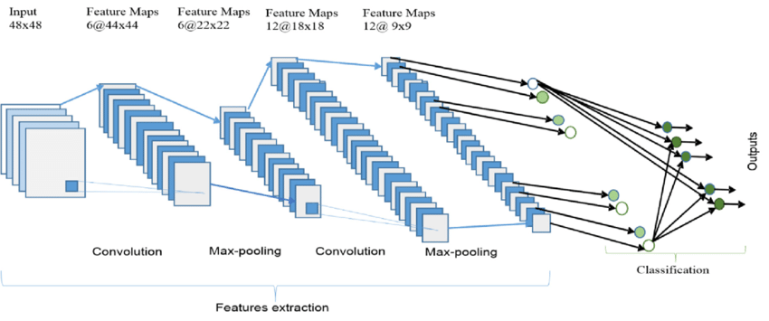

Figure 22: Displays the existing CNN layers as well as how this network compresses the pictures. Source: <https://www.researchgate.net/figure/The-overall-architecture-of-the-Convolutional-Neural-Network-CNN-includes-an-input_fig4_331540139>

## Method & Tools

### Architecture & General Concept

- The architecture of the computer will integrate object-oriented and procedural programming. When the usage of object-oriented programming optimizes and shortens the authoring of code through code reuse. Moreover, procedural programming will be used to optimize the program's execution times.

- The training of the model is performed on our own computer when it is equipped with a powerful GPU suited for deep learning, and the composition of the music is performed on Google Colab, a cloud computing platform that specializes in deep learning and makes use of vast computational resources.

### Centrally-Located Hardware Type

In the initial version, the system will detect emotions on a basic local computer without requiring a network connection.

The music production system will utilize the cloud computing service Google Colab.

### Data Storage

In the initial version, the data will be saved on the local computer where the system is installed in order to minimize execution speeds.

### Operating System

The system is compatible with all operating systems.

### Equipment

A machine with an AMD Ryzen 5 5600X processor and an NVIDIA RTX 3060 graphics card for training the model, and a MAC M1 MAX 32GB.

### Development & Maintenance Tools

Programming language - Python 3.9 will be used to construct the system.

Python is a development-friendly, image processing library-rich, independent programming language that is not dependent on any development environments or operating systems.

Libraries In Use –

- TensorFlow and Keras, two open-source tools for machine learning, will be used to create the neural network model.

- For image processing, we will utilize the OpenCV, scikit-learn,Dlib, MediaPipe, and pandas libraries - image processing and computer vision code libraries.

- NumPy is a mathematical extension package that provides several mathematical functions, vector and matrix multiplication, and more.

- Matplotlib is an extension package that enables the creation of graphs and charts similar to MATLAB.

- NVIDIA CUDA, an interface that connects Python to a graphics card and enables the calculation of neural network models using the graphics card.

Datasets –

- For the goal of identifying facial emotions, we will use FER2013, a collection of photographs of faces arranged according to specific emotions.

- To classify songs according to emotions, we will use MuSe V3, a collection of vocalists and genres organized according to emotions.

Deep Learning Models –

- OpenAI Jukebox, a package including a pre-built neural network model that composes music based on a given input.

- VGGNet architecture - CNN model image classification architecture

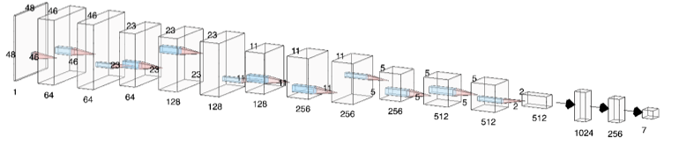

### Body Language Recognition

Currently, there is no public database of emotion recognition based on body language; therefore, we asked 13 people with different specialties (medicine, psychology, social work, and software) to shoot 9 videos of 10 seconds - each 3 videos represent the emotions of sadness, anger, and happiness - in order to build the body language-based emotion recognition model.

Experiment Preparation - 14 participants, excluding the experiment organizers, were asked to classify the above videos (9 videos x 13 persons = 117 total videos).

1) To preserve an emotional classification, the distribution order was chosen at random (each participant receives 7 videos which will not necessarily show the same person in the videos that will be shown between participants).

2) In order to prevent prior knowledge from influencing the classification of the videos, the videos are silent and no prior information is provided.

After classifying the videos according to people, we will train the model using the following data distribution: Training Data - 70%, Validation Data - 20%, and Test Data - 10%, then compare the outcomes of the experiment using the Confusion Matrix.

(Note: the model's code is complete; steps 1 and 2 are required to initiate step 3)

## Realization

### 4.1 – Development Process

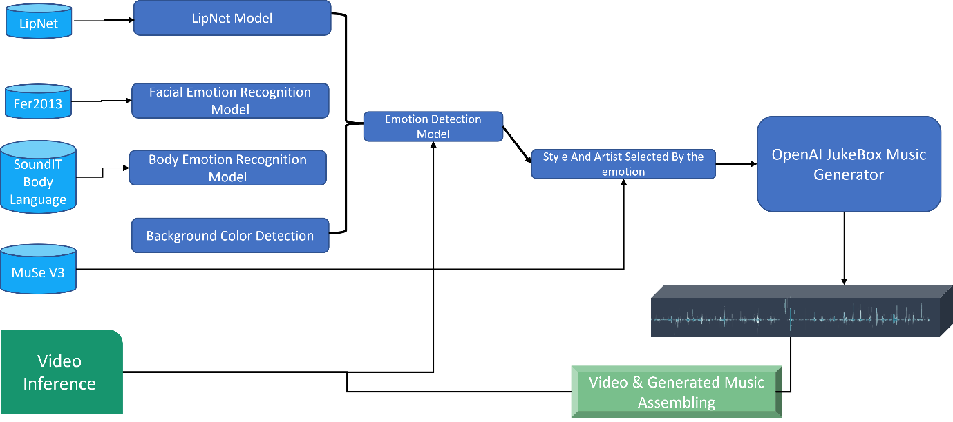

Step 1.1 – Pipeline Development for face emotion detection

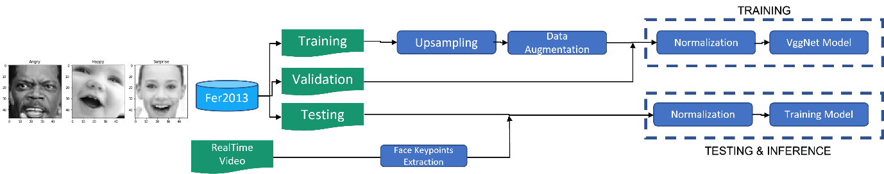

Performance

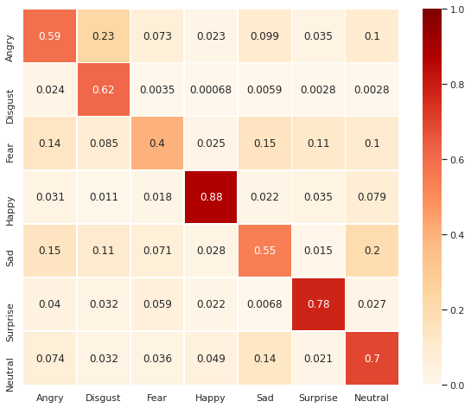

Real-Time Results

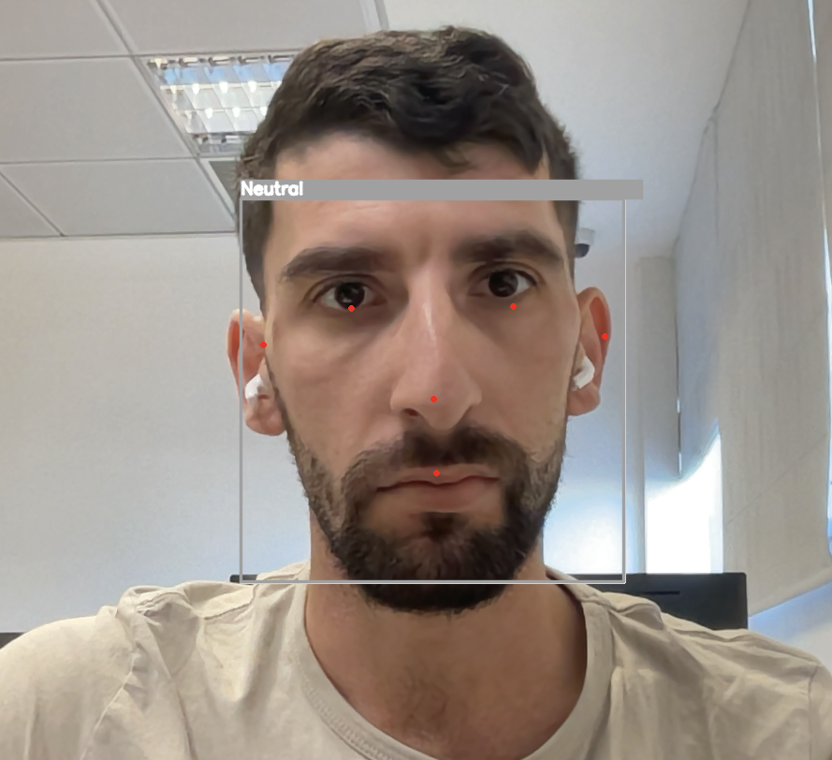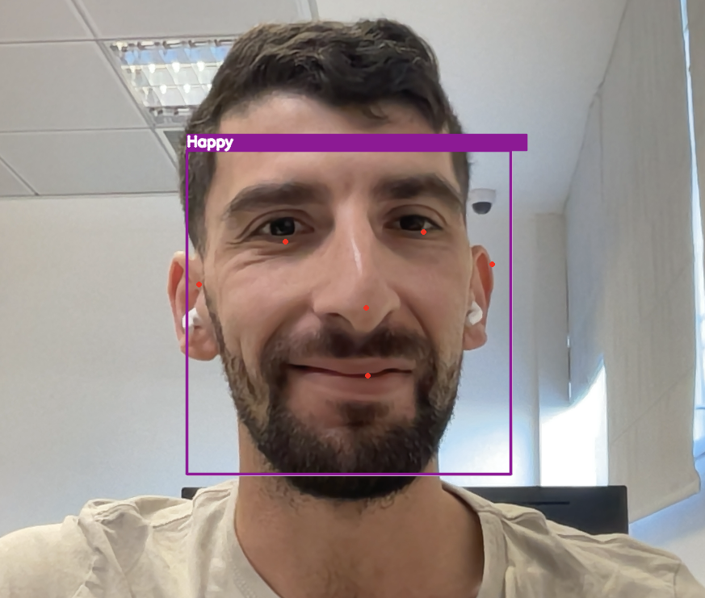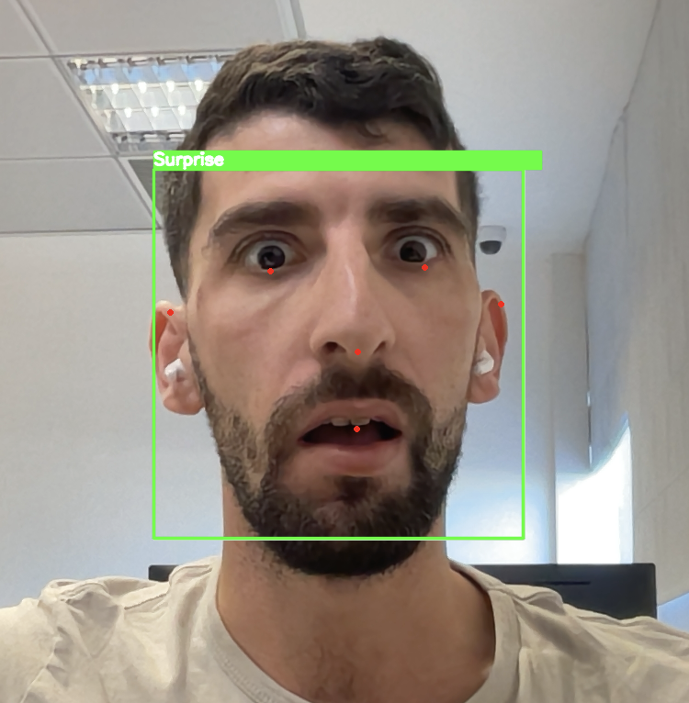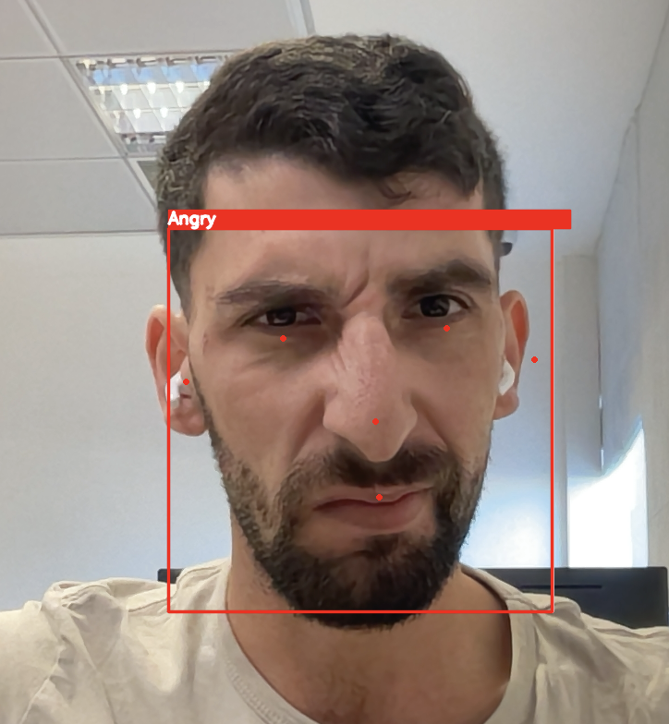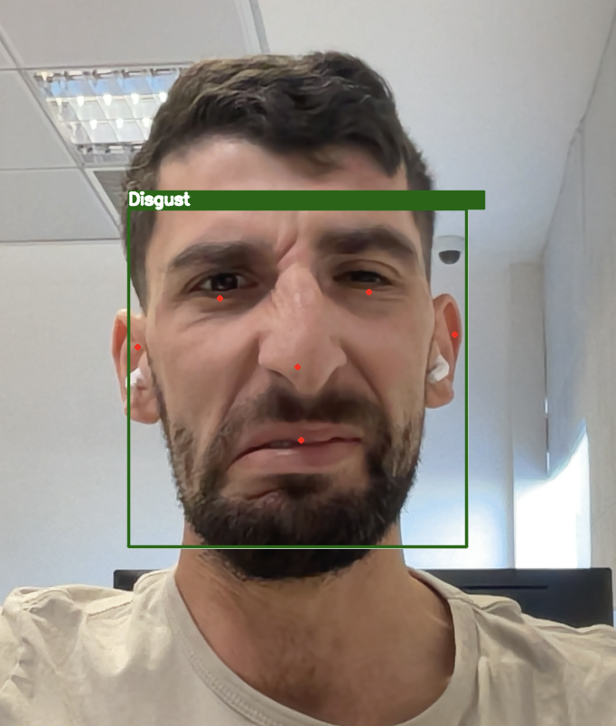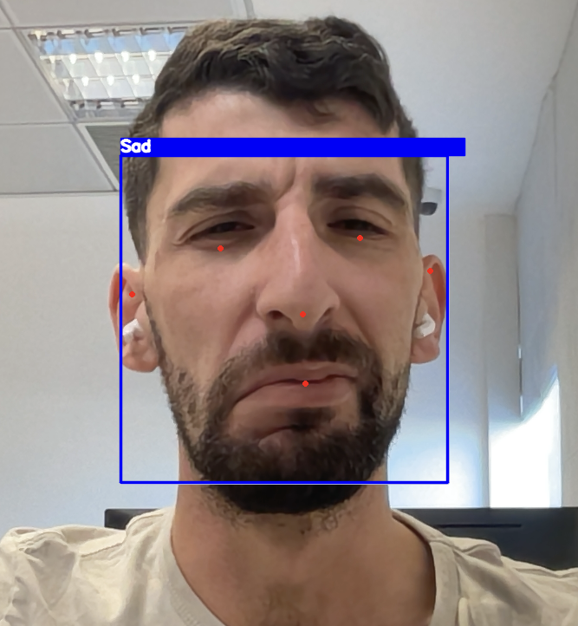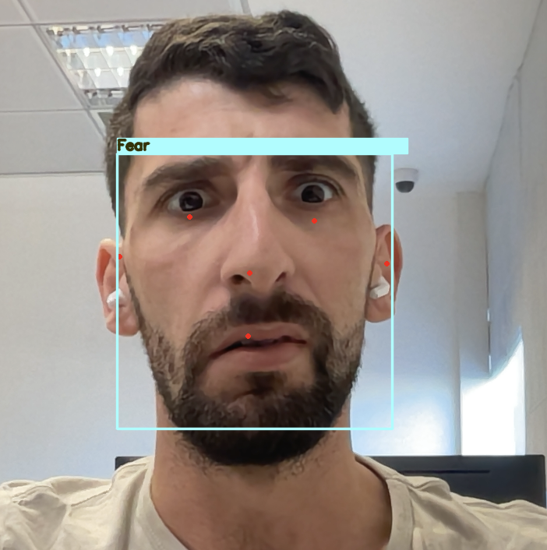

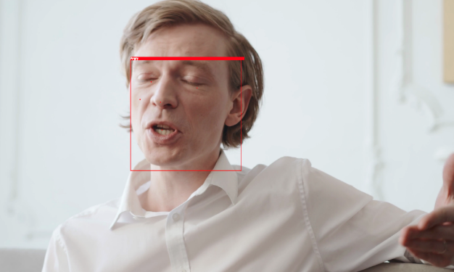

Step 1.2 – Pipeline Development for Body Emotion Recognition

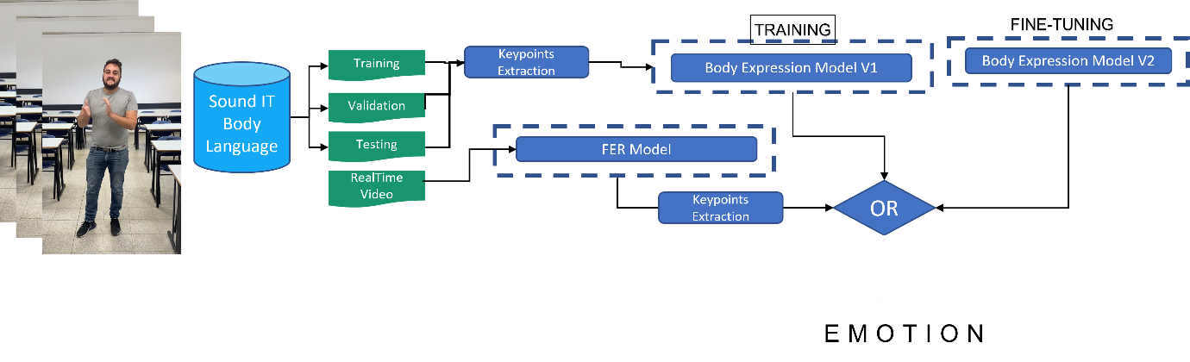

Body Emotion Recognition Architecture

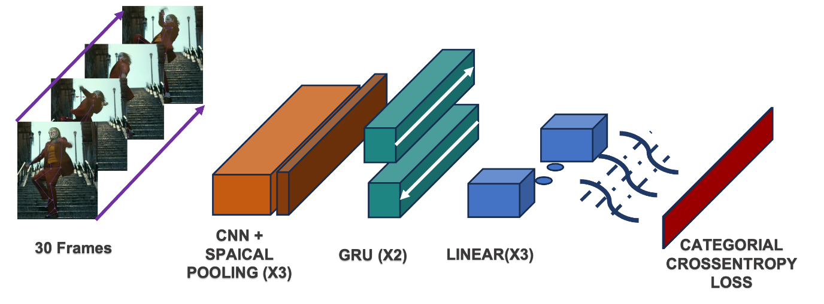

Performance

Happy

Sad :

Angry

Real-Time Results

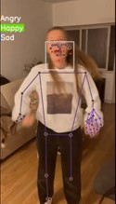

Step 1.3 – Lip Reading Recognition

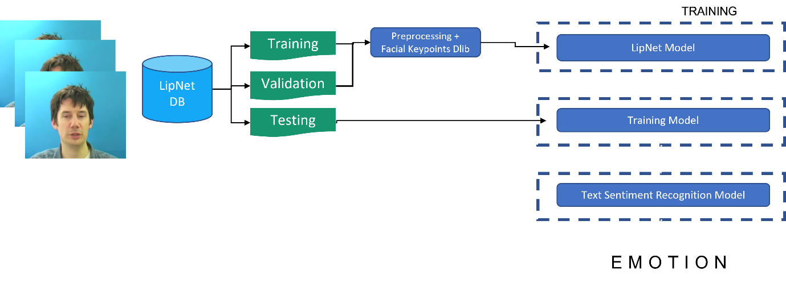

Lip Reading Recognition Architecture

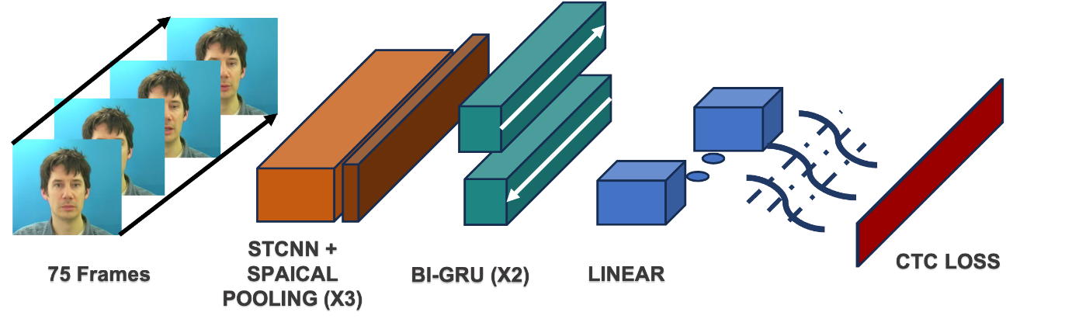

The results from the LipNet dataset are good , but only when the speaker is speaking English. we need to train the dataset on Hebrew speakers to improve the model ,which will be one of our future goals

Real-Time Results



Step 2 - Developing an algorithm to identify a singer and musical genre based on an emotion

Step 3 - Submitting the output to JUKEBOX in order to generate suitable music

Step 4 - manual interpolation between the video and music

Step 5 - Build a Google Form survey with the video, music and video + music files.

Step 6 - Assessing public sentiment and modifying the model accordingly

Step 7 - Finishing the model's development

## Literature Review Summary

Because there is currently no system that can produce music based on body language recognition, facial expressions from a video, or background color, we are going to build a system that will use a neural network and computer vision. This will allow us to produce music based on body language recognition and facial expressions from a video in the most time- and resource-effective manner, which will hopefully give us the best possible results.

# Results

We’ve asked 74 participants from numerous places (SCE, LinkedIn, Facebook, WhatsApp groups) to state the emotion of 25 videos – each form was filled with 3 kinds of videos: silent video, music only and video+music. Each participant were asked to state which emotion best suits the given videos.

The forms were built as shown in the following images:

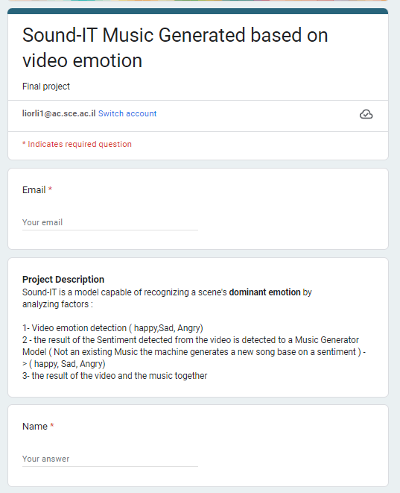

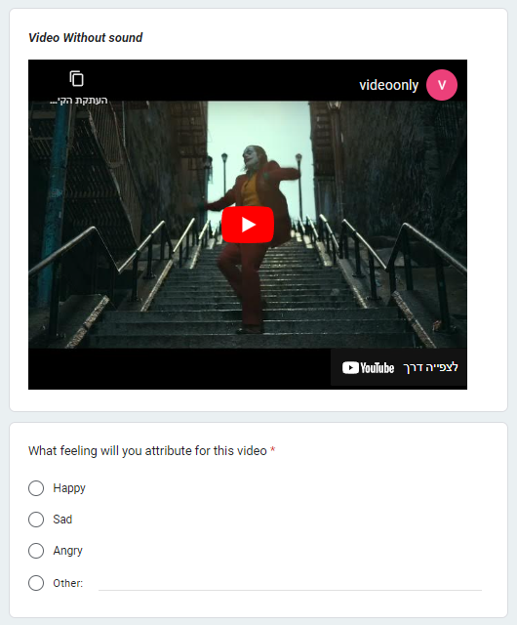

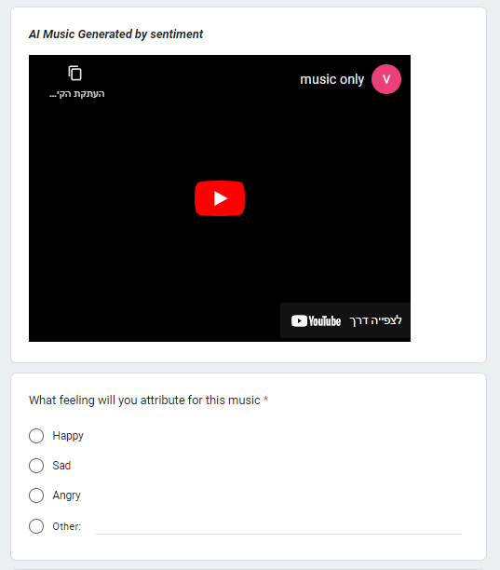

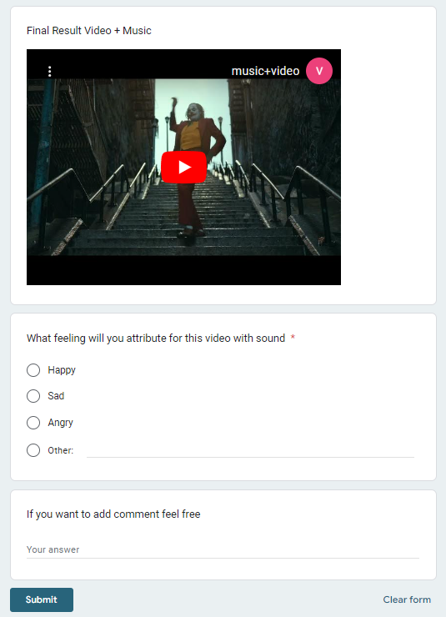

The results were divided as shown:

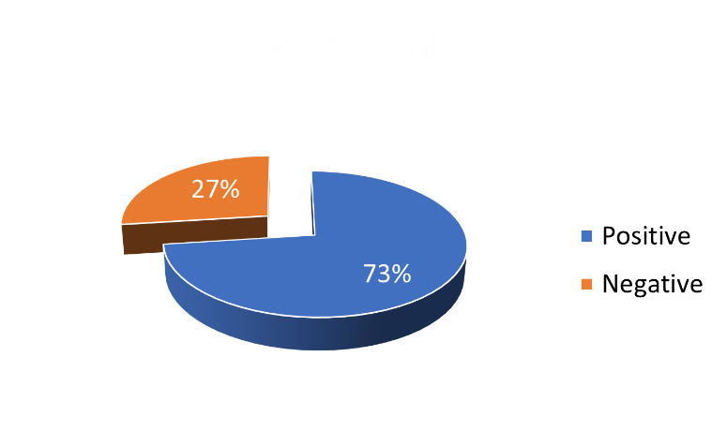

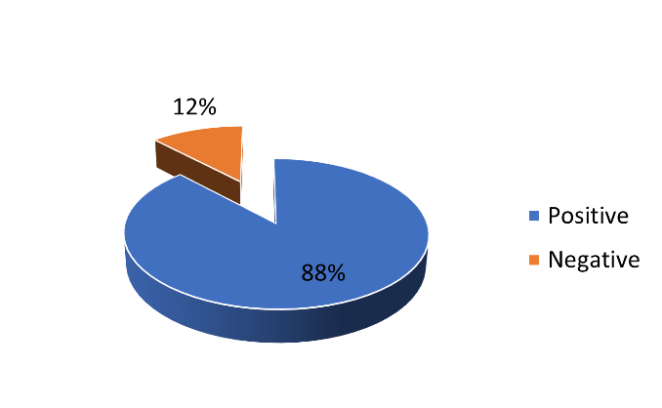The following result is for video only classifications. The emotion that tends to be more difficult to express accurately is anger, since some of the associated body movements are similar to those used when expressing happiness.

The following result is for music only classifications. We have enhanced the emotional impact of music by focusing on rap music to evoke feelings of anger, as metal music tended to elicit feelings of fear.

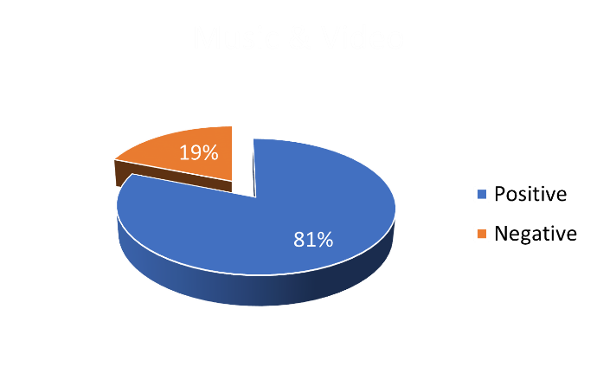

The following result is for music + video classifications. We have enhanced the emotional impact of music by focusing on rap music to evoke feelings of anger, as metal music tended to elicit feelings of fear. After combining both music and video together we’ve got the conclusion that even though the emotion recognized was not the expected emotion the music had an influence on the emotion reflected.

# 3 - Objectives

## 3.1 - Application Client\Expert

### 3.1.1 - Main Client\User

- The film industry

### 3.1.2 - Application Expert\s

- Kevyn Krancenblum and Lior Liberov – The main programmers of the system. 4th year software engineering students at Sami Shimon College Beer Sheva campus.

## 3.2 - Goals

### 3.2.1 – General Background

The primary goal is to develop a system capable of receiving a segment of a film scene and generating music that corresponds to the intended emotional expression of said scene. The identification of the emotional content of a given scene will be accomplished through the utilization of computer vision, deep learning, and a neural network. Specifically, the recognition of body language, facial expressions, and background color will be employed as key indicators of emotional expression. Furthermore, the implementation of a novel model will be undertaken using fresh videos and images, thereby augmenting the efficacy of the system in the event of a significant alteration in the visual representation of a particular emotional state.

### 3.2.2 - Project Goals

- One can determine the emotional tone of a scene by analyzing the nonverbal cues such as body language and facial expressions of the individuals present, as well as the background color.

- The implementation of automated music editing technology can result in significant cost and time savings for film editors, as it eliminates the need for manual editing and purchasing of music from external sources.

- The potential for a forthcoming enhancement to the system.

- The capacity to identify the emotions of multiple individuals simultaneously within a given setting.

### 3.2.3 - Future Goals

- The process of enhancing the accuracy percentages of the model involves training it on supplementary images.

- The inclusion of supplementary emotion recognition capabilities within the system is a potential option.

- The process of training models on cloud servers, such as AWS, IBM CLOUD, AZURE, and others.

## 3.3 - Problems

### 3.3.1 - The crux of the issues in the current scenario.

The utilization of databases containing images and videos of body language is a crucial component in enhancing the precision rates of emotion recognition. Their incorporation is imperative in attaining elevated outcomes.

### 3.3.2 - The issues that the system addresses.

Currently, there is no existing system that is capable of accurately detecting the emotions of actors portrayed in a video. As a result, film editors are often compelled to engage in manual film editing processes and procure music from external sources, which can be both time-consuming and resource intensive. The utilization of our system will enable the editors to economize both time and financial resources during the process of film editing.

### 3.2.3 - Issues that may arise from the system.

One of the primary challenges that may arise pertains to the accurate identification of emotions within a given scene following the implementation of a newly trained model. To address this issue, we propose two potential solutions:

Upon construction of a novel model, an assessment of its accuracy percentages will be conducted, thereby enabling the identification of any potential issues.

Surveys will be compiled, and public opinion will be gathered to assess the accuracy of the model.

## 3.4 - Integration into the organization's objectives - the organizational/business relationship

### 3.4.1 - The organization's objectives, strategy

The system has been designed specifically for application in the film industry.

## 3.5 - Factors involved

### 3.5.1 - Management

The administrative team comprises a single individual.

Dr. Natalia Vanetik, natalyav@sce.ac.il

### 3.5.2 - Professional teams - the development teams

- Mr. Kevyn Krancenblum, Phone: 0584080792, kevinkr@ac.sce.ac.il

- Mr. Lior Liberov, Phone: 0524840194, liorli1@ac.sce.ac.il

# Appendices

## Yearly Work Plan

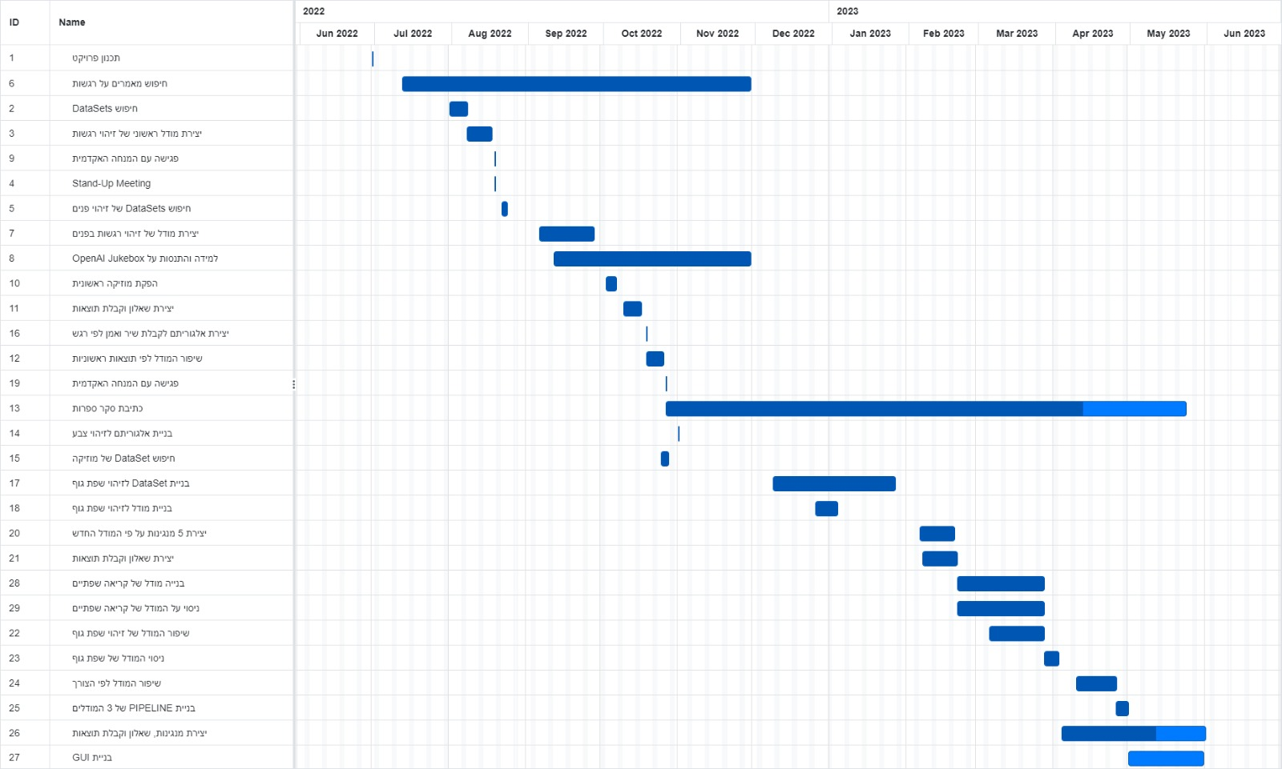

## Risk Management

This section will outline the potential hazards that may arise during the research and development phase of the project.

The categorization of risks will be based on four criteria: category, probability of occurrence, impact or damage potential, and score.

* Probability - the evaluation of the likelihood of a particular risk scenario occurring. On the rating scale, the value of 1 indicates a significantly low level while the value of 5 indicates a significantly high level.
* Impact/Damage - The evaluation of the extent of harm to the project in the event of the occurrence of the specified risk scenario is referred to as impact or damage assessment. On a scale of 1 to 5, 1 represents a significantly low value while 5 represents a significantly high value.
* Score - The formula for calculating the score involves multiplying the probability by the impact or damage.

Risk scores shall be computed in accordance with the subsequent table: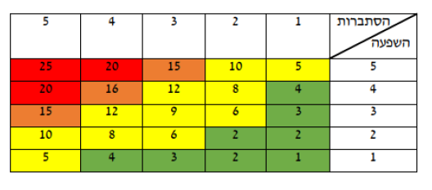

If the grade falls between 1 and 4, the level of risk is deemed insignificant.

The risk posed by the aforementioned situation is noteworthy, however, it falls towards the lower end of the hierarchy of concerns that require attention.

- 19-14 The potential hazard carries substantial weight and necessitates prompt attention.

- 25-20 The risk factor is of utmost importance for the seamless progression of the project and is accorded top priority.

|  |  |  |  |  |  |
| --- | --- | --- | --- | --- | --- |
| **Risk** | **Category** | **Probability** | **Impact/Damage** | **Score** | **Treatment** |
| **The training images exhibit substandard quality.** | Technical | 3 | 4 | 12 | We intend to enhance the quality of the images by upscaling them. |
| **Insufficient familiarity with the subject matter within the realm of research.** | Research | 4 | 3 | 12 | Conducting a thorough investigation of the subject matter through the examination of scholarly articles and seeking guidance from professionals within the respective field. |
| **Lack of pictures for training** | Technical | 3 | 5 | 15 | We will endeavor to procure images from online sources and/or from professionals with expertise in the relevant subject matter. |
| **The inaccessibility of Google Colab for system utilization.** | Technological | 3 | 3 | 9 | The utilization of comparable services. |
| **The inadequate amalgamation of the model and the ultimate application.** | Technological | 4 | 5 | 20 | We intend to engage in online courses and conduct comprehensive research in the respective field. |
| **The inaccurate identification of facial expressions.** | Technological | 5 | 5 | 25 | Enhancing the model and incorporating additional data. |
| **Non-adherence to established timelines.** | Technical | 4 | 5 | 20 | Using a GANTT chart that is continuously updated, manage deadlines and requirements. |
| **Incorrect lip reading identification** | Technological | 4 | 5 | 20 | Enhancing the model and incorporating additional data. |

# Bibliography

Lambert, A' J', Eadeh, F' R', Peak, S' A', Scherer, D' L', Schott, J' P', & Slochower, J' M'. (2014). Toward a Greater Understanding of the Emotional Dynamics of the Mortality Salience Manipulation: Revisiting the “Affect-Free” Claim of Terror Management Research. *Journal of Personality and Social Psychology*, 1-18.

Aiken, M', & Bsat, M'. (1999). Forecasting Market Trends with Neural Networks. *Information Systems Management, Volume 16, Issue 4*, 42-48.

Akiki, C', & Burghardt, M'. (2020). Toward a Musical Sentiment (MuSe) Dataset for Affective Distant Hearing. *CHR 2020: Workshop on Computational Humanities Research*, 225-235.

Assael, Y' M', Shillingford, B', Whiteson, S', & de Freitas, N'. (2016). LipNet: End-to-End Sentence-level Lipreading. *arXiv*.

Bakker, I', van der Voordt, T', Vink, P', & de Boon, J'. (2014). Pleasure, Arousal, Dominance: Mehrabian and Russell revisited. *Springer Science+Business Media New York*, 2-6.

Dhariwal, P', Jun, H', Payne, C', Kim, J' W', Radford, A', & Sutskever, I'. (2020). Jukebox: A Generative Model for Music. *arXiv:2005.00341*.

Dubois, J', & Adolphs, R'. (2015). Neuropsychology: How Many Emotions Are There? *Elsevier*, 1-2.

Hamann, K', & Smith, R'. (2019). Facial Recognition Technology - Where Will It Take Us? *Criminal Justice*, 1-2.

Lee, J' R', Wang, L', & Wong, A'. (2020). EmotionNet Nano: An Efficient Deep Convolutional Neural Network Design for Real-time Facial Expression Recognition. *arXiv*.

Lindsey, D'. (1951). Emotion. ב- S' S' Stevens, *Handbook of experimental psychology* (עמ' 473-516). Wiley.

LIONS GATE ENTERTAINMENT CORP. (2022). *ANNUAL REPORT PURSUANT TO SECTION 13 OR 15(d) OF THE SECURITIES EXCHANGE ACT OF 1934.* Vancouver, British Columbia: LIONS GATE ENTERTAINMENT CORP.

Liu, Z', & Huang, J'. (2019). Semantic segmentation network of uav image based on improved U-net. *IOP Conference Series: Earth and Environmental Science*.

Mingming, C', Jiandong, F', & Yudong, Z'. (2020). Emotion recognition of human body's posture in open environment. *Chinese Control and Decision Conference*, 1.

Mollahosseini, A', Hasani, B', & Mahoor, M' H'. (2017). AffectNet: A Database for Facial Expression, Valence, and Arousal Computing in the Wild. *IEEE TRANSACTIONS ON AFFECTIVE COMPUTING*.

Pavlovic, I', & Markovic, S'. (2011). The effect of music backgroundon the emotional appraisal of film sequences. *PSIHOLOGIJA Vol. 44 (1)*, 76-84.

Plutchik, R'. (2001). The Nature of Emotions. *American Scientist, Volume 89*, 347,349.

Shu, L', Xie, J', Yang, M', Li, Z', Li, Z', Liao, D', . . . Yang, X'. (2018). A Review of Emotion Recognition Using Physiological Signals. *MDPI*, 4.

Suwarno, K'. (2020). Analysis of Face Recognition Algorithm: Dlib and OpenCV. *Journal Of Informatics And Telecommunication Engineering*, 1.

Valdez, P', & Mehrabian, A'. (1994). Effects of Color on Emotions. *Journal of Experimental Psychology*, 394-409.

Wang, X', Yu, K', Wu, S', Gu, J', Liu, Y', Dong, C', . . . Tang, X'. (2018). ESRGAN: Enhanced Super-Resolution Generative Adversarial Networks. *arXiv:1809.00219*.